BEFORE THE BOARD OF FIRE COMMISSIONERS

OF THE CAPAY VALLEY FIRE PROTECTION DISTRICT

RESOLUTION NO. 25-1

RESOLUTION OF INTENTION TO CONTINUE ASSESSMENTS FOR FISCAL YEAR 2025-26 PRELIMINARILY APPROVING THE ENGINEERS REPORT, AND PROVIDING FOR NOTICE OF PUBLIC HEARING FOR THE CAPAY VALLEY FIRE PROTECTION DISTRICT, FIRE PROTECTION

AND EMERGENCY RESPONSE SERVICES ASSESSMENT

WHEREAS, on August 14, 2023 by Resolution No. 23-06, the Capay Valley Fire Protection District (the “District”) Board of Fire Commissioners (the “Board”) authorized the levy of assessments for the formation of a fire protection and emergency response services assessment district pursuant to Health and Safety Code section 13914, Government Code sections 50078—50078.20 and Cal. Const. art. XIIID to provide improved fire suppression (also referred to as fire protection) services, as further described herein, for all the properties within the boundaries of the District; and

WHEREAS, such fire protection and emergency response services provide life and property protection and other special benefits to the public and properties within the areas of such services; and

WHEREAS, the purpose of the Assessment is for fire response and emergency response services which include increased firefighter staffing and training and improved maintenance and replacement of apparatus and equipment throughout its boundaries (collectively “Services”).

WHEREAS, the District is authorized, pursuant to the authority provided in Health and Safety Code section 13914, and Government Code sections 50078—50078.20 and Article XIIID of the California Constitution, to levy assessments for fire suppression and emergency response services; and

WHEREAS, the Assessment was authorized by an assessment ballot proceeding conducted in 2023 and approved by 75.71% of the weighted ballots returned by property owners, and such assessments were levied by the Board by Resolution No. 23-06, passed on August 14, 2023; and

WHEREAS, an annual adjustment to the Assessment rate equal to the change in the Consumer Price Index for the San Francisco-Oakland-Hayward Consumer Price Index for All Urban Consumers (CPI-U), not to exceed 5% per year was also authorized by the assessment ballot proceeding conducted in 2023;

NOW, THEREFORE, BE IT RESOLVED by the BOARD OF COMMISSIONERS OF THE CAPAY VALLEY FIRE PROTECTION DISTRICT AS FOLLOWS:

1. SCI Consulting Group, the Engineer of Work, prepared an engineer’s report in accordance with Article XIIID of the California Constitution and Government Code sections 50078—50078.20 (the "Report"). This report contained the methodology and apportionment for the FY 23-24 assessment. The Report was deemed sufficient and preliminarily approved in Resolution 2023-05. The Board of Commissioners of the Capay Valley Fire Protection District finds that the methodology of the assessment has not changed. The Report shall stand as the Engineer's Report for all subsequent proceedings under and pursuant to the foregoing resolution with an addendum describing the current year proposed budget and updated assessment roll.

1. It is the intention of this Board to continue to collect assessments for the fire protection and emergency response services assessment for fiscal year 2025-26 for the proposed projects and services set forth in the Report. Within the Capay Valley Fire Protection District, the proposed projects and services are generally described as fire prevention and emergency response services as well as capital costs, and maintenance and operation expenses (“Services”).
2. The authorized maximum assessment to be levied in future fiscal years shall not be adjusted at this time.
3. The estimated fiscal year 2025-26 cost of providing the Services is $134,227.50 This cost results in a proposed assessment rate for fiscal year 2025-26 of ONE HUNDRED EIGHTEEN AND TWENTY-TWO CENTS ($118.22) per single-family equivalent benefit. Reference is hereby made to the Report for a full and detailed description of the proposed assessments upon assessable lots and parcels of land.

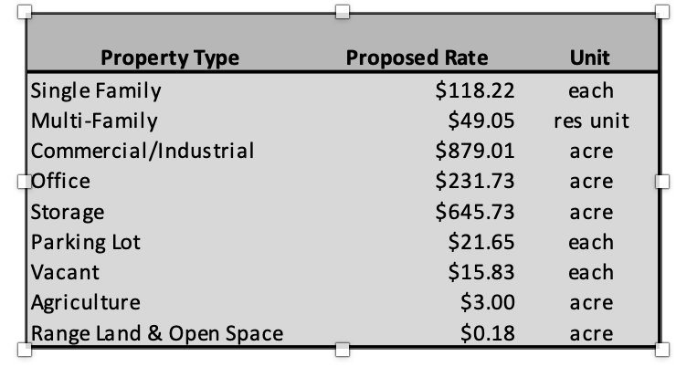

5. Notice is hereby given that on August 11, 2025, at the hour of 6:30 p.m. at Capay Valley Fire Protection District offices, located at 7447 State Hwy 16, Guinda, CA 95637, the Board will hold a public hearing to consider the ordering the continuation of the Services, and the levy of the assessments for fiscal year 2025-26.

1. The clerk of the board or designee shall cause a notice of the hearing to be given by publishing a notice, at least ten (10) days prior to the date of the hearing above specified, in a newspaper circulated in the District.

PASSED and ADOPTED by the Board of Commissioners of the Capay Valley Fire Protection District, this 28th day of July 2025, by the following vote:

AYES:

NOES:

ABSENT:

_________________________

Board Chair

ATTEST:

___________________________

District Secretary